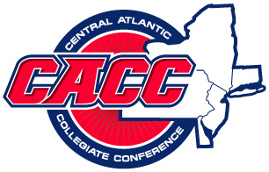


CHARGERS BASEBALL

BY THE NUMBERS

1986-2007

760 Winning % at Home
716 Winning % in the CACC
615 Number of Total Wins- Averaging 29 Wins a Season
549 Career Wins for Coach Giannetti
114 All CACC Players
60 Players Named to All-American Team
42 # of Victories in 2006, Most Ever by a Rockland County Team & CACC BASEBALL TEAM
27 Game Winning Streak vs. District Opponents (1987-1989)
24 # of Players Signing Professional Contracts
24 Regular Season Conference Victories, Most Ever by A CACC Team (2006)
21 CACC Play-Off Bids
16 CACC CHAMPIONSHIPS
14 REGIONAL PLAY-OFF BIDS
2 WORLD SERIES APPEARANCES (1997 & 1999)
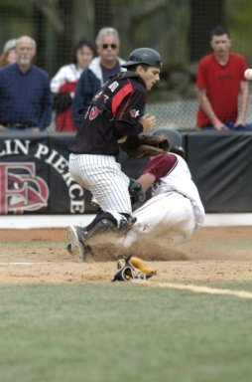
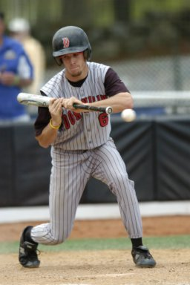
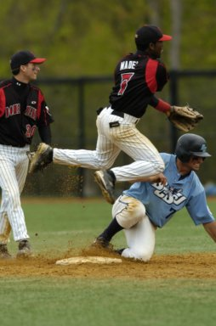
1 ONE GOAL-WIN THE CACC CHAMPI

